**Set Up a Single Node Cluster using Google Cloud Instance**

# Step 1: Access into https://cloud.google.com to register account

You will get $300 credit for 1 year

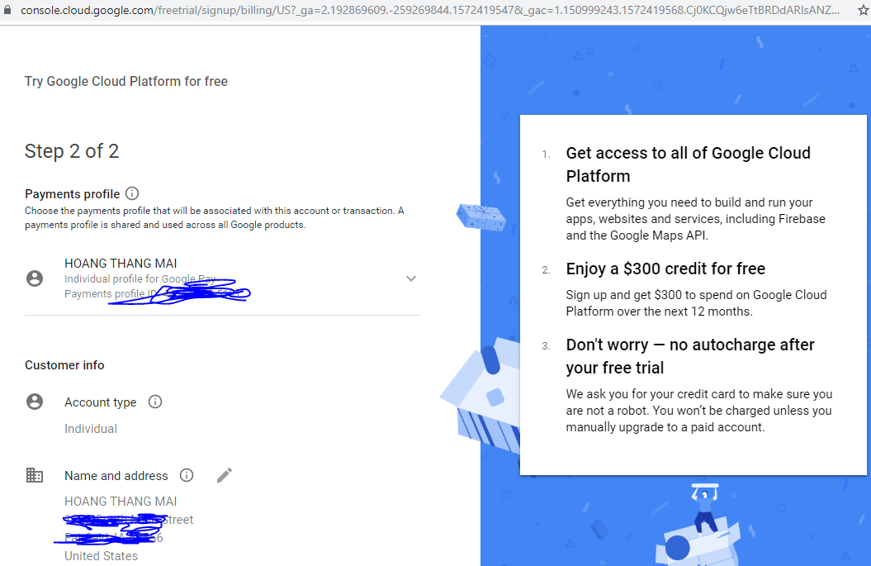

# Step 1: Create a new project

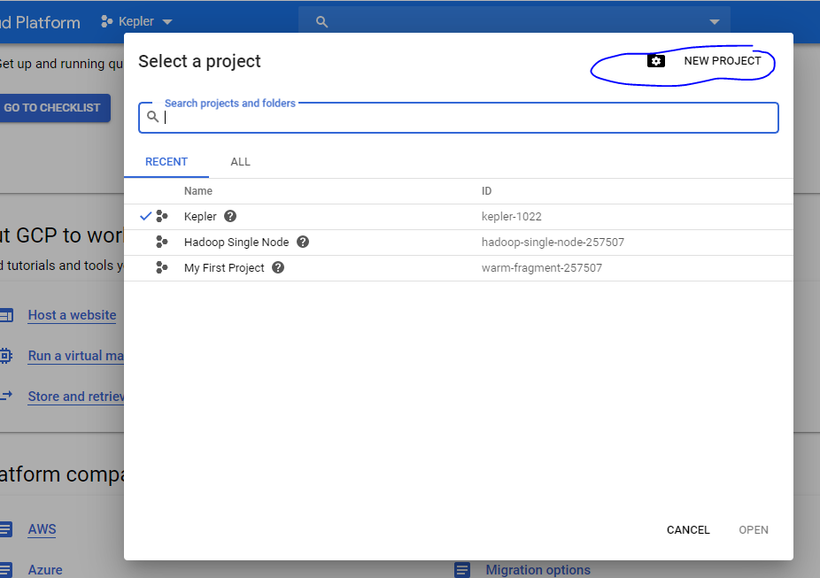

# Step 3: Init an instance

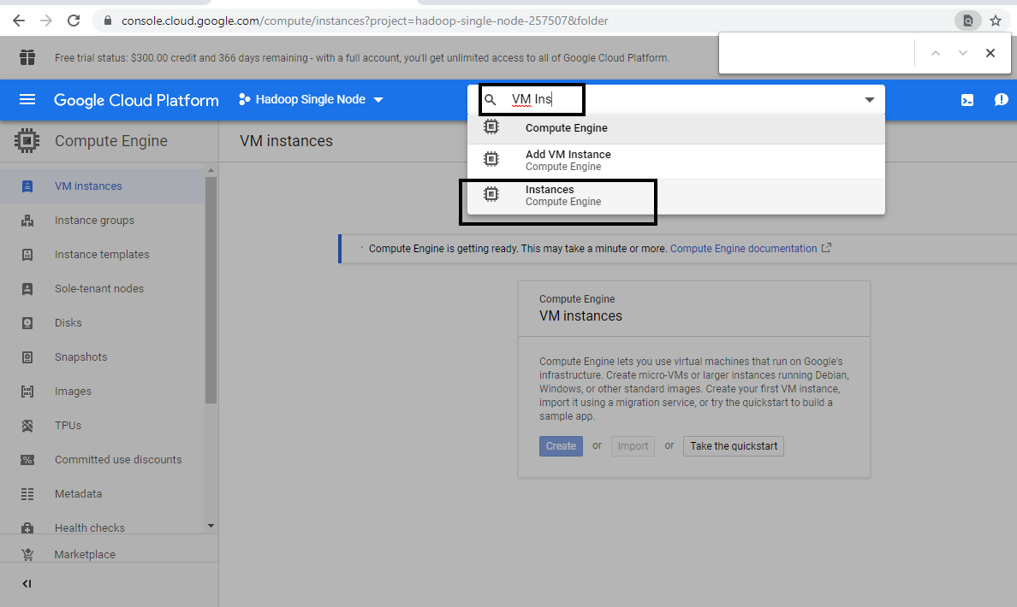

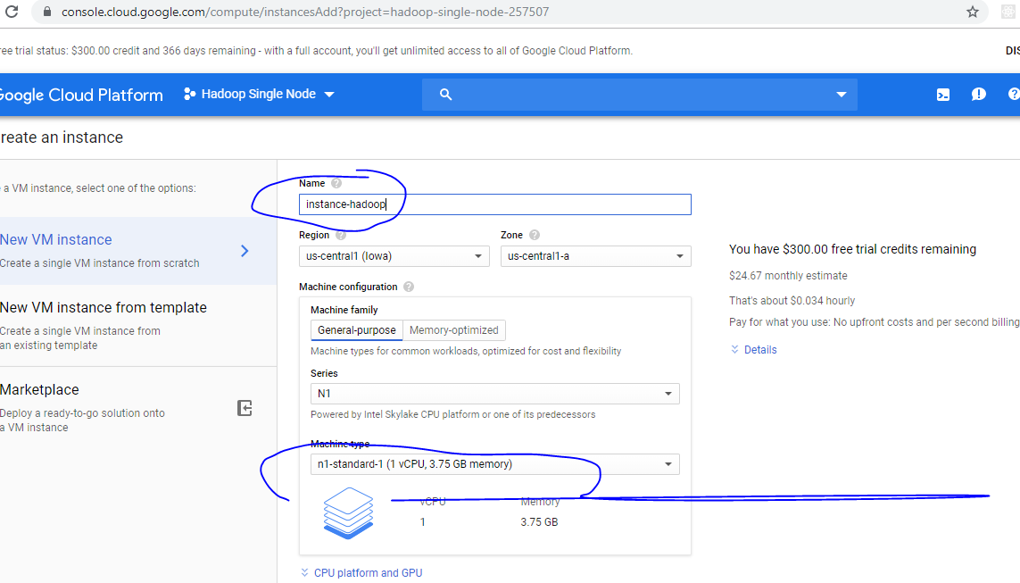

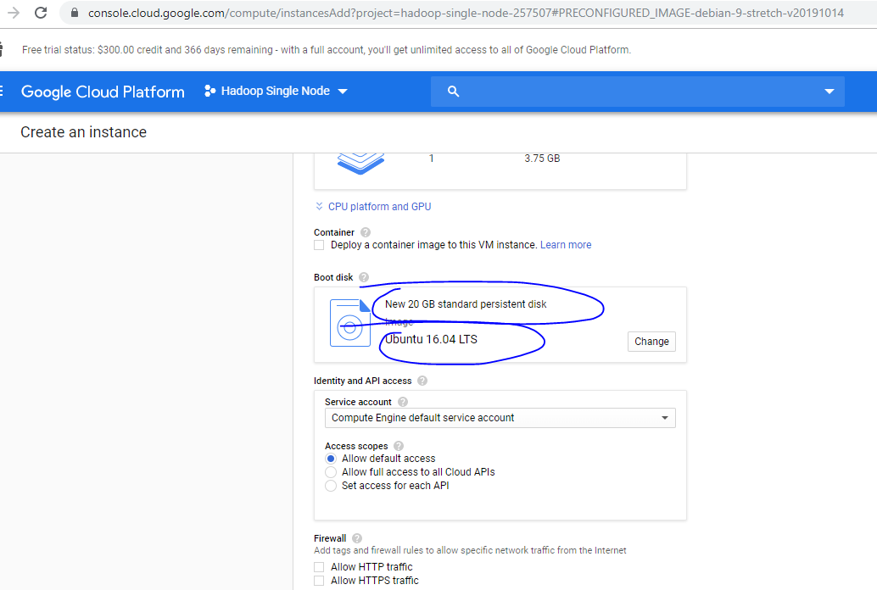

Recommend 20Gb hard-disk because we will have to download cloudera 4.7Gb then extract.

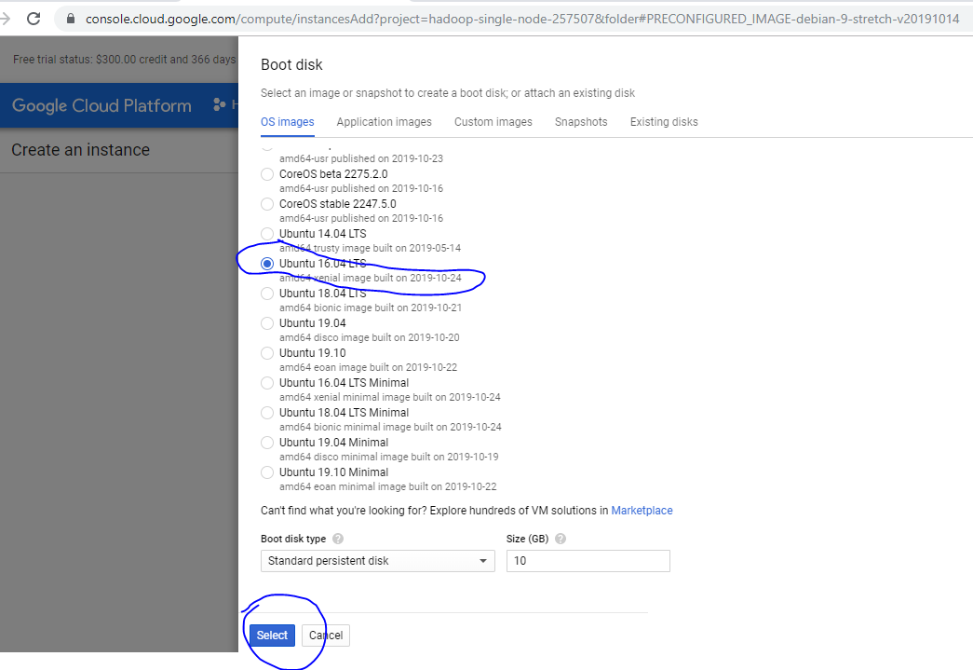

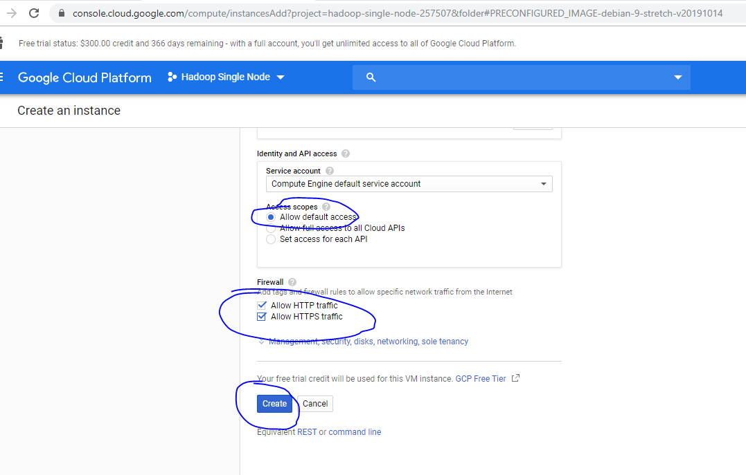

# Step 4: SSH to the instance

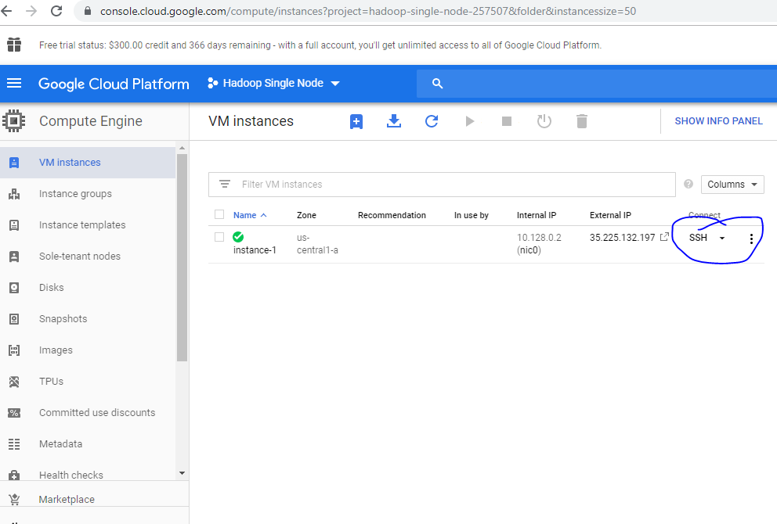

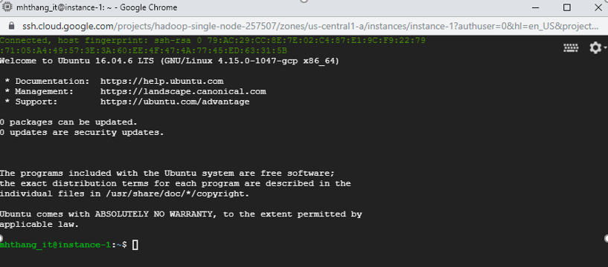

# Step 5: get Docker and update

curl -ssl https://get.docker.com/ | sh

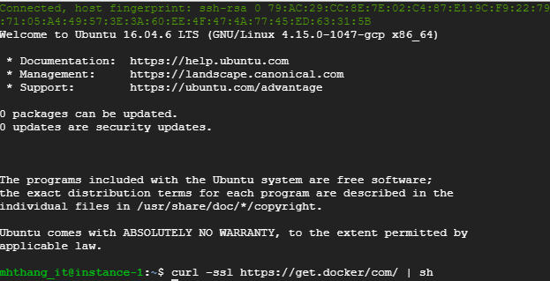

sudo apt-get update

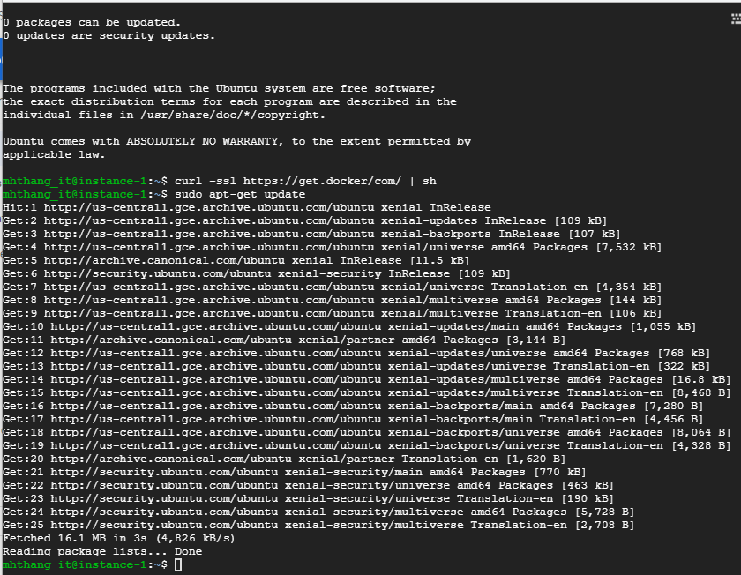

Check version of docker

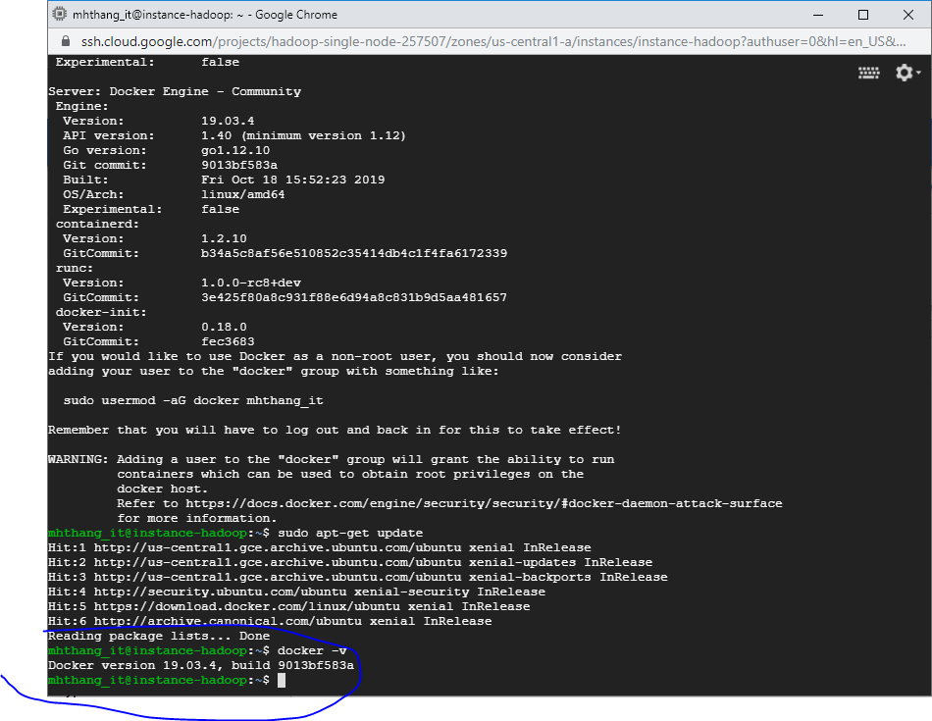

# Step 6: Get the Cloudera Quickstart Image

sudo wget <https://downloads.cloudera.com/demo_vm/docker/cloudera-quickstart-vm-5.13.0-0-beta-docker.tar.gz>

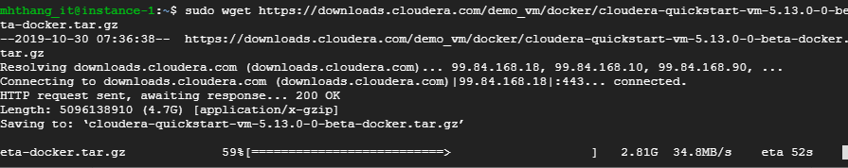

# Step 7: Extract the cloudera quickstart tar file

tar xzf cloudera-quickstart-vm-*-docker.tar.gz

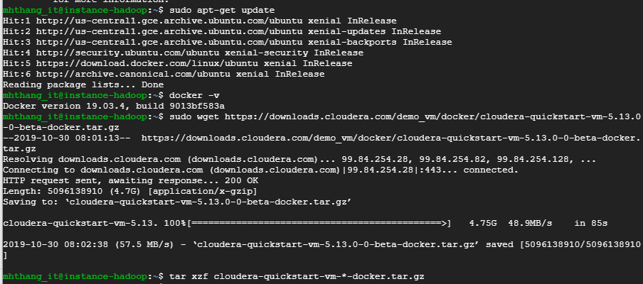

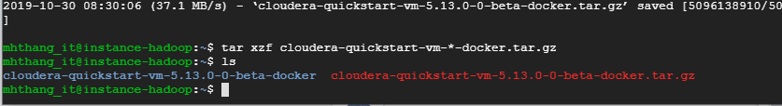

# Step 8: Import Cloudera quickstart docker image

cd cloudera-quickstart-vm-5.13.0-0-beta-docker

sudo docker import cloudera-quickstart-vm-5.13.0–0-beta-docker.tar

Remove downloaded file if short of disk space

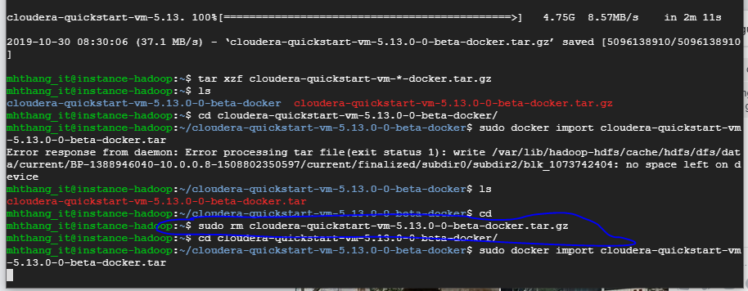

# Step 9: Check the container image ID

sudo docker images

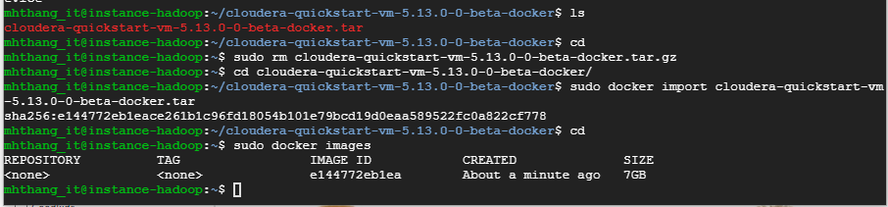

# Step 10: Step Run docker image

sudo docker run --hostname=quickstart.cloudera --privileged=true -t -i -p 8777:8888 -p 7190:7180 -p 90:80 e144772eb1ea /usr/bin/docker-quickstart

***Now, we are ready to run Hadoop, example with wordcount map reduce. Step to create and export Hadoop project, ref to Set Up a Single Node Cluster using VM or Docker document.***

# Step 11: Create folder

[root@quickstart ~]# hadoop fs -mkdir /user/cloudera/wordcount /user/cloudera/wordcount/input



# Step 11: Create documents

echo "Hadoop is an elephant" > file0

echo "Hadoop is as yellow as can be" > file1

echo "Oh what a yellow fellow is Hadoop" > file2

hadoop fs -put file* /user/cloudera/wordcount/input

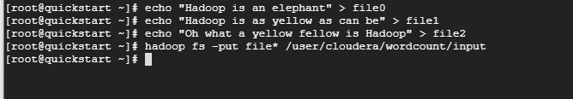

# Step 12: Load *.jar file into cloudera

In this step, the wordcount.jar is downloaded from an hyperlink. You can find another way to copy file from your machine into google cloud instance.

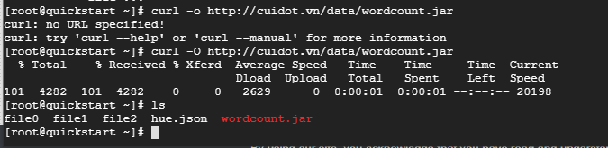

# Step 13: Run the WordCount application from the JAR file we created on Eclipse, giving the paths to the input and output directories in HDFS.

hadoop jar wordcount.jar org.myorg.WordCount /user/cloudera/wordcount/input /user/cloudera/wordcount/output

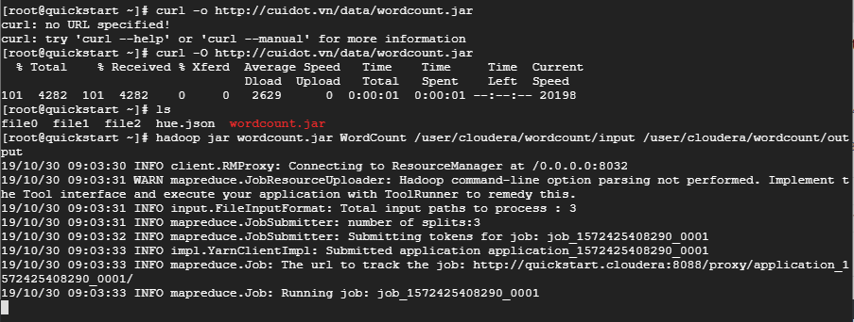

Result:

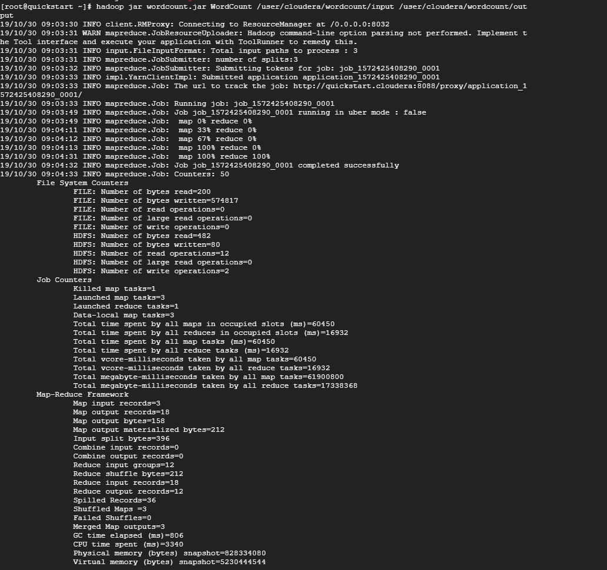

Good Luck